

Practical Report

For IoT Practical



January 1, 2022

Darshan Ramjiyani (DSP)

DOCS, KSKV Kachchh University

* **4.1 Serial Communication**

Serial communication is a communication method that uses one or two transmission lines to send and receive data and that data is continuously sent and received one bit at a time

Baud Rate: Specify the transfer rate at which data will be transfer through Serial Communication.

9600 Baud rate means it can pass 9600 bits per seconds(bps) through Serial Communication.

* **Code:**

int number = 1;

int baudRate = 9600;

void setup()

{

/* Established Serial Communication. */

  Serial.begin(baudRate);

  /* Wait until Serial Communication not established. */

  while(!Serial){}

  /* Send data through Serial Communication. */

  Serial.println("(*) First Program (*)");

  Serial.println("- Name of Author : DSP -");

  Serial.println("---------------------------------------------------------");

}

void loop()

{

  Serial.print(number); // print in countinouse line.

  Serial.print(",");

  delay(2000); // wait for 2 seconds.

  number++;

}

* Output:

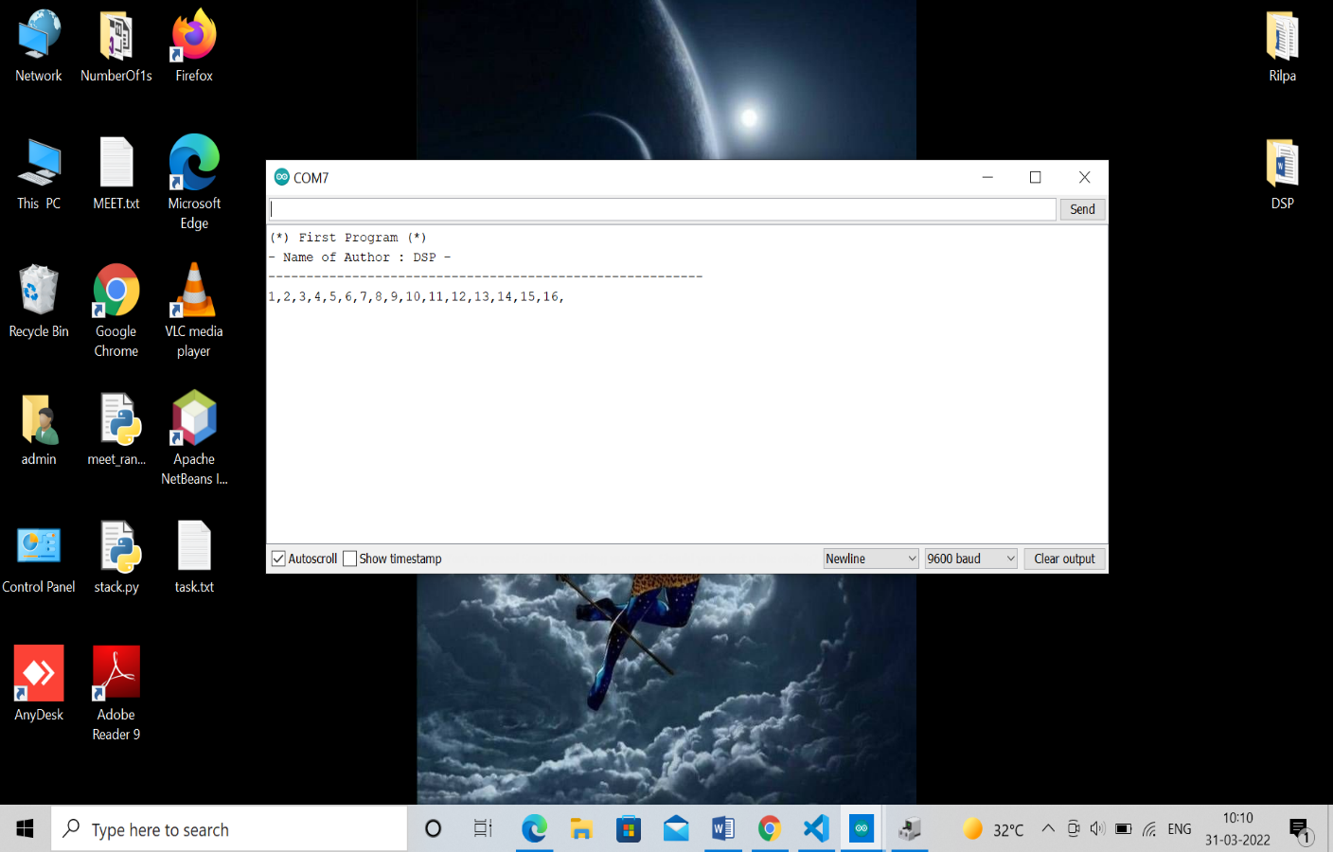

Output From Dwaidh Terminal